# How To: Upload to Pavlovia

Pavlovia is a repository where we can store experiments and potentially run them online. It helps you organise your workflow as you can store your experiments on the GitLab repository, you can track versions and you can make your experiments public.

1. Create an account <https://gitlab.pavlovia.org/users/sign_in> Click the **Register** tab, and ensure that you use your @hope.ac.uk email address for this site [1]
2. Connect PsychoPy Builder with Pavlovia by opening your experiment in Builder. Click **Pavlovia.org** on the toolbar then **User🡪 Log in to Pavlovia**
3. Log in using the username and password that you provided in step 1

There are a number of ways to upload and sometimes you will encounter an error. For the most part you can ignore this error if you can see in Runner that the experiment has synced

### Primary Method

#### Uploading Via PsychoPy Builder

1. Click **Pavlovia.org🡪New** to create a new project
2. Provide a **Name** for your project (a good suggestion is to use your student number suffixed by dissertation)
3. Click **Browse** in the Local Folder row to navigate to your PsychoPy Builder root folder
4. Click **Create Project on Pavlovia**
5. This method often throws the error “attribute error:’NoneType’ object has no attribute ‘project’, click **OK** and the **Runner** window will open along with a **Committing changes** box
6. In the **Summary of changes** make a brief note of the stage of development (this could be *first commit* to Pavlovia, or correcting an error). There is also space for a more detailed account of changes made. Click **OK**
7. The **Stdout** box in the **Runner** window should then show a message referring to *pushing files to Pavlovia* and a statement of *success* or *failure*
8. You can update your experiment on Pavlovia using the **Sync** function on the toolbar. You should see a message in the **Stdout** box to say that it was successful (or not as the case may be)

Once you have a final fully working version online, it is a good idea to make a clean copy and use that as the working experiment to present to participants. The reason for this is that you will have test datafiles (delete before upload and sync) and if you have made any changes in the structure of the experiment, then the data files will not match up, and merging them for analysis will be problematic.

## Secondary Method

#### Uploading via GitLab

1. When you create your Pavlovia account, this automatically provides you with a Git Lab account. Sign in to your gitlab repository using the Pavlovia email and password <https://gitlab.pavlovia.org/> and you should see a screen that contains any projects that you have already uploaded as in Figure 1

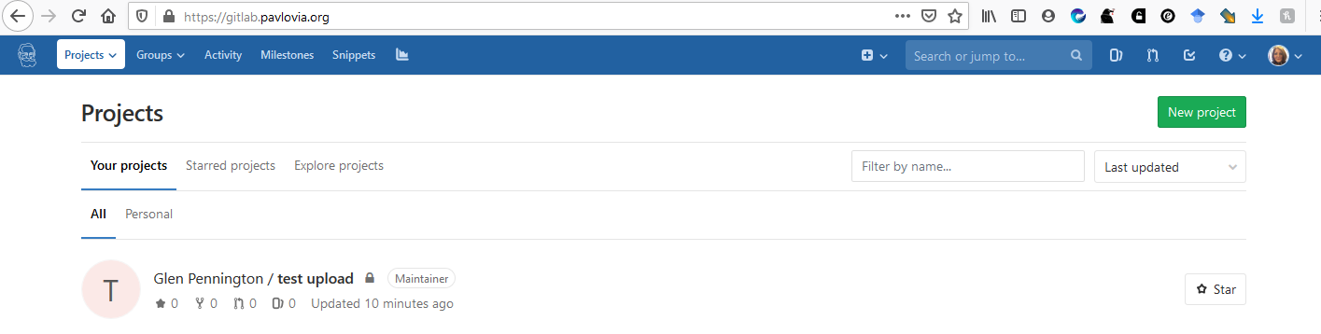

Figure 1

1. Create a **New Project** by clicking the green button as in Figure 1
2. Name your project with your **student number and name** and click **Create project** (see Figure 2)
3. 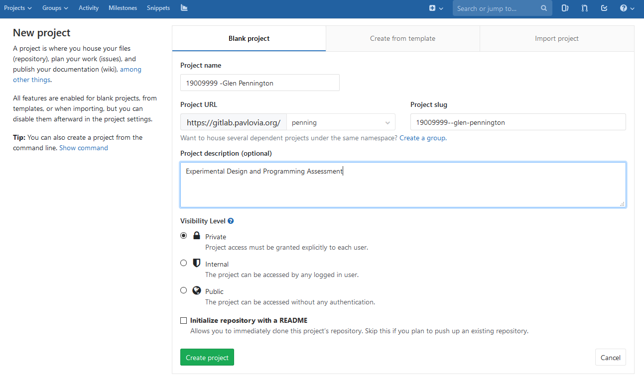You now have an empty repository that should look similar to this

Figure 2

1. 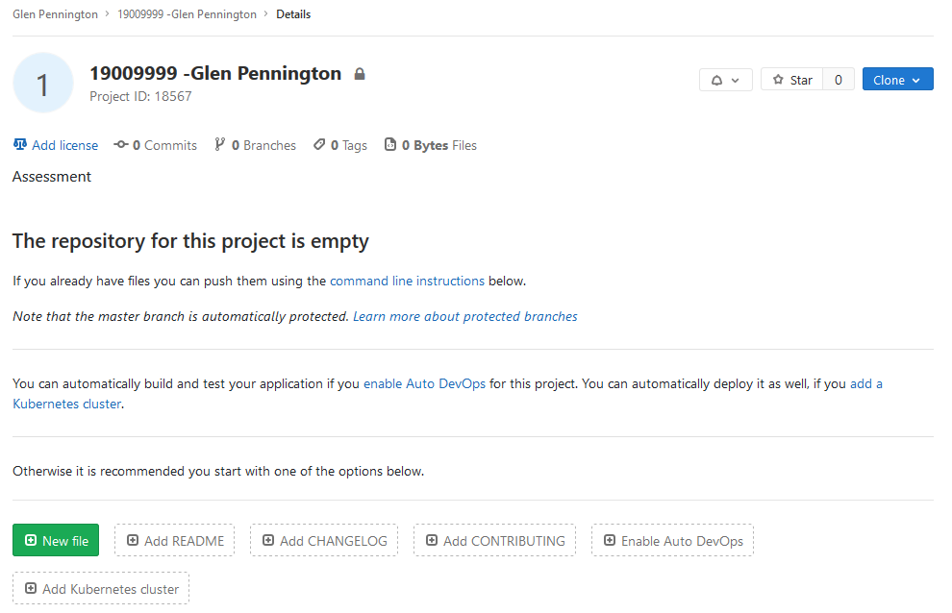Click on the **New File button** and in the textbox, type in **assessment,** and click **Commit changes**

Figure 3

1. This will return you to the repository. Click on your **student number and name link**

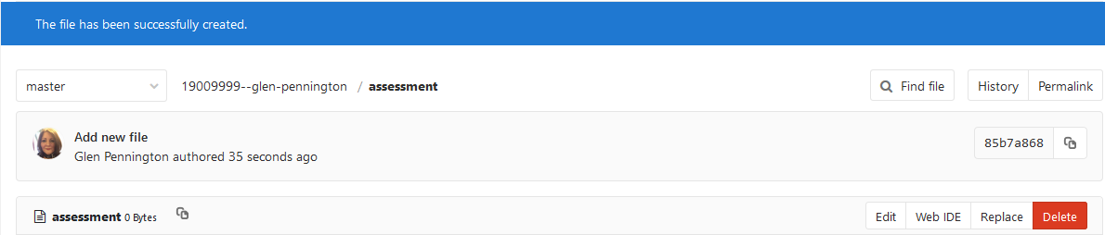

Figure 4

1. 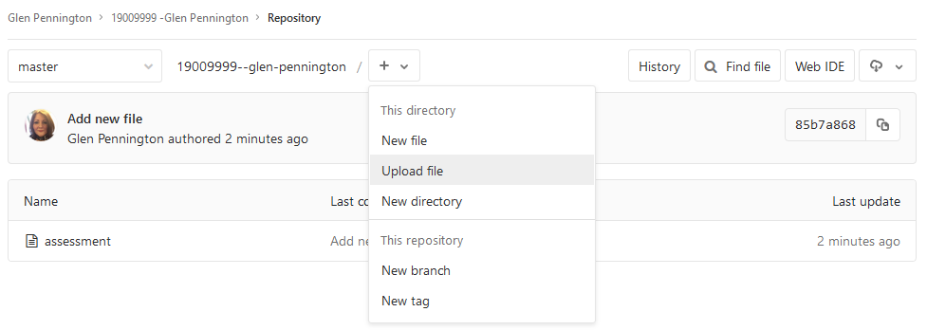Next you should click on the **+ symbol 🡪 Upload file**
2. You can now drag and drop files or use click to upload. Currently you must upload one file at a time. Repeat from Step 6 until you have uploaded your experiment, read me and conds files

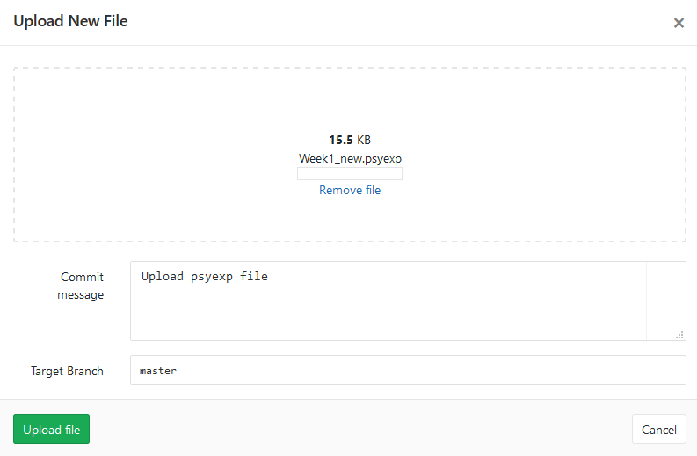

Figure 5

1. You now need to create a folder for your stims if required. To create a new folder, click the **+ symbol🡪New directory** and name it stims or protocol as appropriate (Figure 6)

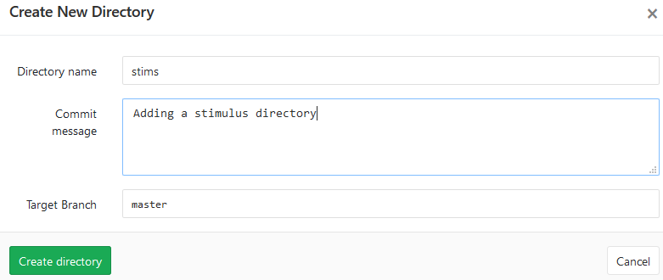

Figure 6

1. To add files to your new folders, ensure that you are in the folder you want to add files to and follow the same steps from 6 onwards.
2. Your repository should look similar to the one in Figure 8.

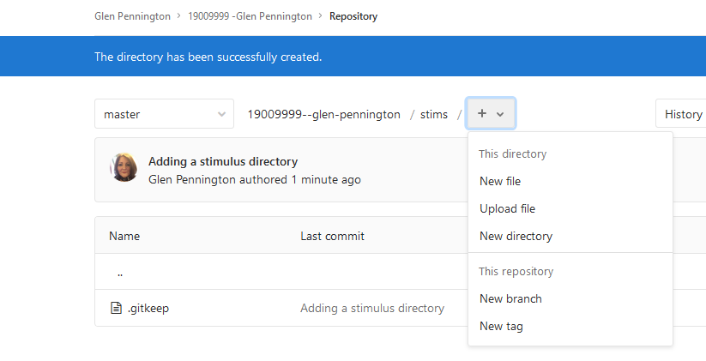

Figure 7

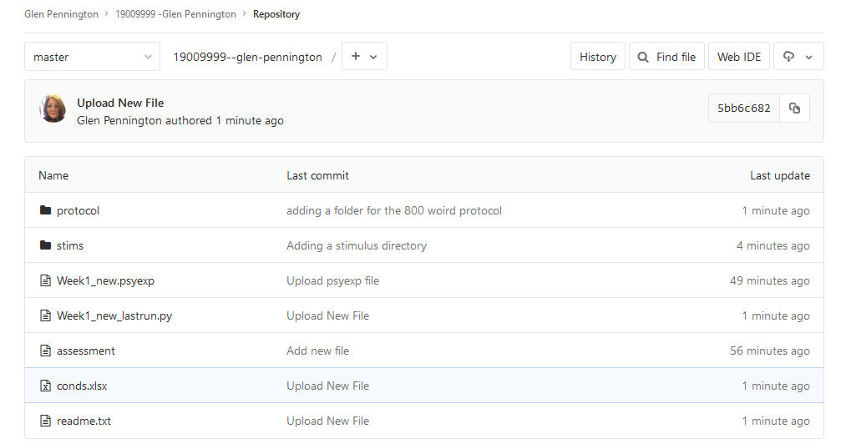

Figure 8

1. Remember to go to **Settings🡪Members** and add your tutor as a Maintainer

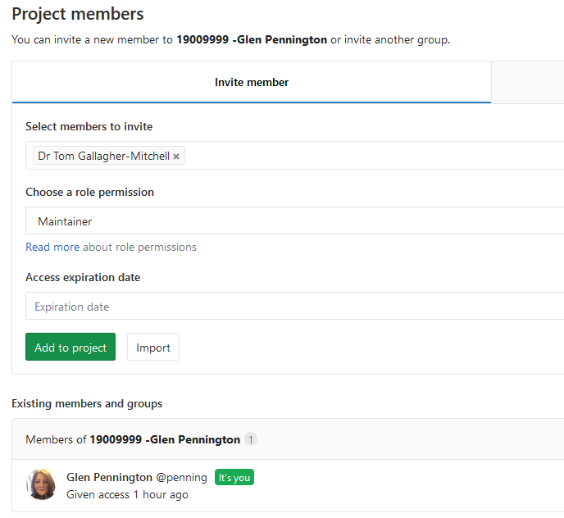

Figure 9

1. If you use any other email address you will need to pay for credits to run studies, with your @hope email address you can run studies online